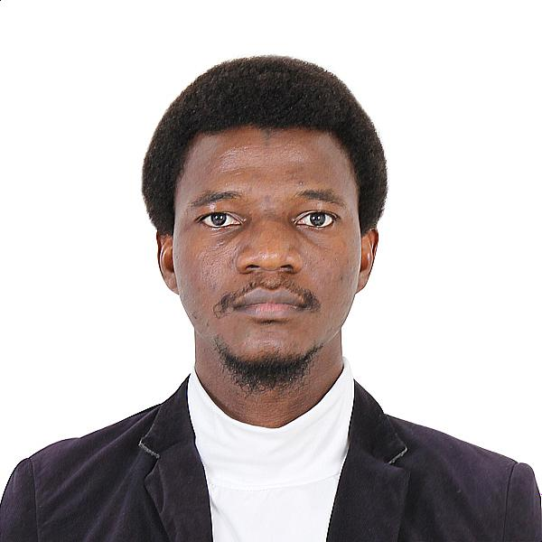

Naheem holds a bachelor degree in Surveying and Geoinformatics from the federal university of Technology Akure, Nigeria and a master degree in Civil and Environmental Environmental Engineering from the University of Teknology Petronas, Malaysia. For his master thesis, he conducted a holistic evaluation of the current and future trend in coastal sea level and shoreline dynamics across the 21 tide gauge stations along Malaysia coastline using geospatial technology and machine learning. He is currently a PhD student in the department of Geophysics BSU where he is being supervised by HP Marshall. His research focuses on investigating InSAR and machine learning techniques for estimating snow.